Capstone Project Report
on
PLC-Based Mixing Motor
Control System

Submitted in partial fulfillment of
the requirements of the Third Year of
Bachelor of Technology In
Electronics and Computer Science by
Navyashri.C [EU1247046] Drashti Shetty[EU1247044] Riya Singh [EU1247003]
Shruti Thakur [EU1247030]

Under the Guidance of

Ms. Hiral Patel


Assistant professor, Department of electronics and computer science,SJCEM

DEPARTMENT OF ELECTRONICS AND COMPUTER SCIENCE ST. JOHN COLLEGE OF ENGINEERING & MANAGEMENT UNIVERSITY OF MUMBAI
2026-2027

Certificate of Approval

This is to certify that the following student(s) of T. Y. B.Tech. in the Electronics and Computer Science Department have satisfactorily completed the requirements for the course Programmable Logic Controllers and SCADA prescribed by ST. JOHN COLLEGE OF ENGINEERING AND MANAGEMENT (An Autonomous College affiliated to the University of Mumbai), while working on the project “PLC-Based Mixing Motor Control System.”

NavyaShri.C [EU1247046]
Drashti Shetty[EU1247044]
Riya Umesh Singh[EU1247003]
Shruti Thakur [EU1247030]

Signature:  Name : Ms. Hiral Patel  Ass. Professor | Signature:  Name : Dr. Md. Immadudin HOD

Signature: External Signature:
Name: Dr. Kamal Shah Principal,
St. John College of Engineering and Management.

Declaration

I/we declare that this written submission represents my/our ideas in my/our own words and where others ideas or words have been included, I/we have adequately cited and referenced the original sources. I/we also declare that I/we have adhered to all principles of academic honesty and integrity and have not misrepresented or fabricated or falsified any idea/data/fact/source in my/our submission. I/we understand that any violation of the above will be cause for disciplinary action by the Institute and can also evoke penal action from the sources which have thus not been properly cited or from whom proper permission has not been taken when needed.

Signatures:

NavyaShri.C [EU1247046]

Drashti Shetty [EU1247044]

Riya Umesh Singh [EU1247003]

Shruti Thakur [EU1247030]

Date

ACKNOWLEDGEMENT

We sincerely thank our project guide Ms.Hiral Patel for her guidance and support for carrying out our Project. We thank our HOD Dr. Md. Immadudin for his valuable time and provision of departmental facilities. We thank Principal Dr. Kamal Shah for the infrastructure and maintenance. We also thank lab assistants for their help and practical guidance.

Student name

NavyaShri.C [EU1247046]
Drashti Shetty[EU1247044]
Riya Umesh Singh[EU1247003]
Shruti Thakur [EU1247030]

Abstract

The PLC-Based Mixing Motor Control System demonstrates the use of Mitsubishi MELSOFT GX Works3 and Ladder Diagram programming to implement industrial control logic using an FX5U PLC.
The visible ladder program incorporates input contacts, a holding circuit using internal relay M0, output coils Y0, Y1 and Y2, and timer T0 with preset K100. These elements illustrate how PLC instructions can be combined to control output states according to input conditions and programmed logic.
The supplied screenshots establish the structure of the visible ladder program. However, confirmation of the complete mixing sequence, timer duration, physical output assignments and overall operational performance requires the corresponding project configuration and test evidence.
The project provides a basis for studying PLC programming, internal relay operation, contact logic, timer-controlled behavior and ladder monitoring in an industrial automation application.

CONTENTS

Chapter No. | Topic | Page No.
CHAPTER 1 | OVERVIEW | 1
1.1 | Introduction | 1
1.2 | Background | 1
1.3 | Importance of the Project | 1
1.4 | Perspective of Stakeholders and Customers | 2
1.5 | Objectives and Scope of the Project | 2
CHAPTER 2 | LITERATURE SURVEY & PROPOSED | 3
2.1 | WORK | 3
2.2 | Introduction | 3
2.3 | Literature Survey Table | 4
2.4 | Problem Definition | 4
2.5 | Feasibility Study | 4
 | Methodology Used
CHAPTER 3 | ANALYSIS AND PLANNING | 5
3.1 | Introduction | 5
3.2 | Project Planning | 5
CHAPTER 4 | DESIGN & IMPLEMENTATION | 6
4.1 | Data Flow Diagram (DFD) | 6
4.2 | Block Diagram | 6
4.3 | Flow Chart | 7
4.4 | UML & PLC Ladder Diagram | 7
CHAPTER 5 | RESULTS & DISCUSSION | 9
5.1 | Actual Results | 9
5.2 | Future Scope | 9
CHAPTER 6 | CONCLUSION | 10
REFERENCES |  | 11

CHAPTER 1: OVERVIEW

Introduction
The PLC-Based Mixing Motor Control System is designed to automate the operation of a mixing process using a Programmable Logic Controller (PLC). The system is programmed using Mitsubishi MELSOFT GX Works3 software, with Ladder Diagram (LD) programming. The PLC executes the control logic based on input conditions and controls the connected outputs according to the programmed sequence. The visible program includes a start/holding circuit using internal relay M0, output control using Y0 and Y1, and a timer instruction T0. Another rung controls output Y2 using timer and contact logic. The primary purpose of PLC-based control is to provide an organized and repeatable method of controlling industrial operations through programmed logic. The exact physical functions of the individual outputs depend on the hardware connections and device assignments.

Background

Programmable Logic Controllers are widely used in industrial automation to control machines and processes. They replace complex hardwired relay-control arrangements with programmable logic that can be modified according to process requirements. Ladder Diagram programming represents control logic using contacts, coils, timers, and branches. The PLC evaluates these instructions during its program execution cycle and updates the relevant outputs according to the logic and hardware configuration.

In the present project, Mitsubishi MELSOFT GX Works3 is used to develop and monitor the ladder program for an FX5U PLC. The program contains input conditions X0, X1, X2 and X3, an internal relay M0, outputs Y0, Y1 and Y2, and timer T0.

Importance of the Project

Automated Control: The PLC executes programmed control logic without requiring continuous manual switching.
- Holding Circuit: Internal relay M0 provides a holding path in the start-control rung.
- Sequential Control: Contacts and timer instructions determine the conditions under which outputs are energized.
- Programmable Operation: The control sequence can be modified through the PLC programming software.
- Monitoring and Troubleshooting: GX Works3 provides ladder monitoring facilities that help users observe the program's execution

Perspective of Stakeholders and Customers

- Machine Operators: Can operate the system through the connected input devices, subject to the actual hardware configuration.
- Maintenance Personnel: Can inspect the ladder logic and monitor PLC devices to help identify control faults.
- Industrial Automation Engineers: Can modify and maintain the program according to process requirements.
- Plant Supervisors: Can benefit from repeatable programmed operation and easier integration with other control equipment.

  - Objectives and Scope of the Project

- To develop a ladder-logic program using Mitsubishi MELSOFT GX Works3.
- To implement a start/holding circuit using input X0, input X1 and internal relay M0.
- To control outputs Y0, Y1 and Y2 through programmed input and timer conditions.
- To incorporate timer-based control using timer T0.
- To monitor the ladder program and understand the operation of its contacts, branches, coils and timer instruction.

The project covers PLC-based control logic development and monitoring for a mixing motor application. It includes input-condition processing, internal relay operation, timer-based control and output switching. The physical assignment of each output and the complete mixing sequence must be established from the hardware configuration and project documentation

CHAPTER 2: LITERATURE SURVEY & PROPOSED WORK

Introduction

PLC-based automation systems are used in industrial processes that require reliable control of motors, actuators and other electrical equipment. Ladder Diagram programming provides a graphical method of representing relay-based logic and timer-controlled operations.

Literature Survey Table
Sr. No. | Title of Paper / System | Authors & Year | Technology Used | Limitations / Research Gap
1 | PLC-Based Batch Mixing System | Mbeah and Normanyo (2024) | PLC, Ladder Logic, SCADA | Focuses on pharmaceutical batch mixing with SCADA. The proposed project uses a Mitsubishi FX5U PLC with GX Works3 and a simpler ladder-logic arrangement.
2 | PLC-Based Industrial Motor Control | Mahalakshmi et al. (2022) | PLC, SCADA, VFD, Ladder Logic | Covers a range of industrial drive applications rather than the specific mixing-motor logic used in this project.
3 | PLC-Based Stepper Motor Control | Chong et al. (2015) | PLC, Stepper Motor, Ladder Diagram | Focuses on stepper-motor speed anddirection control rather than timer-based mixing-motor operation.
4 | Verification of PLC Ladder Diagrams | Chambers et al. (2001) | PLC, Ladder Logic, Formal Verification | Focuses on verifying ladder logic rather than implementing a physical mixing-motor control system.

Problem Definition
Manual control of industrial mixing equipment can require repeated operator intervention. PLC-based control provides a method for implementing the required input conditions, holding logic, timing and output switching within a single programmable controller. The project addresses the development of a ladder-logic control program for a mixing motor application. The visible program contains a holding circuit, output-control rungs and a timer-controlled section.

Feasibility Study

- Technical Feasibility: The program is developed using Mitsubishi MELSOFT GX Works3 for an FX5U PLC. The visible instructions include digital-device contacts, an internal relay, output coils and a timer.

- Operational Feasibility: Ladder Diagram programming provides a visual representation of the control sequence. The program can be monitored in GX Works3 to observe its logical operation.

- Economic Feasibility: A numerical economic assessment cannot be established from the available project material because component costs, installation costs and comparative operating costs have not been provided.

  - Methodology Used
The project follows a PLC programming and monitoring methodology.
- Requirement Identification: Determine the intended operating sequence and the required input and output devices.
- PLC Configuration: Configure the FX5U PLC in MELSOFT GX Works3.
- Ladder Program Development: Create the contacts, internal relay, output coils, timer and branches.
- Program Execution: Execute or monitor the program using the available PLC environment.
- Logic Observation: Observe the states of the relevant contacts, coils and timer.
- Verification: Compare the observed behavior against the intended operating sequence.

CHAPTER 3: ANALYSIS AND PLANNING

Introduction
The development of a PLC-based mixing control system requires planning of the control sequence, device allocation, ladder-logic implementation and testing procedure. The control logic must define the conditions under which the system starts, remains active, changes output states and stops. Timer operation must also be checked to ensure that the actual behavior matches the intended process.

Project Planning
Table 2: Project Planning & Phase Breakdown

Phase | Activity Description | Deliverable | Duration
Phase 1 | Requirement Analysis & Literature Review | Problem Statement & Component Selection | Weeks 1–2
Phase 2 | PLC Hardware Requirement Analysis & I/O Identification | PLC Input/Output Assignment Table | Weeks 3–4
Phase 3 | PLC I/O Mapping & Ladder Logic Development in GX Works3 | Simulated & Verified .gx3 Ladder Program | Weeks 5–7
Phase 4 | Timer Configuration & Internal Relay Implementation | Timer-Controlled Ladder Logic | Weeks 8–9
Phase 5 | Output Control & Mixing Motor Sequence Development | Output Control & Mixing Motor Sequence Development | Weeks 10–11
Phase 6 | System Testing, Logic Verification & Report Preparation | Final PLC Program & Capstone Report | Week 12

CHAPTER 4: DESIGN & IMPLEMENTATION

Data Flow Diagram (DFD)
Figure 1: DFD Level 0 & Level 1

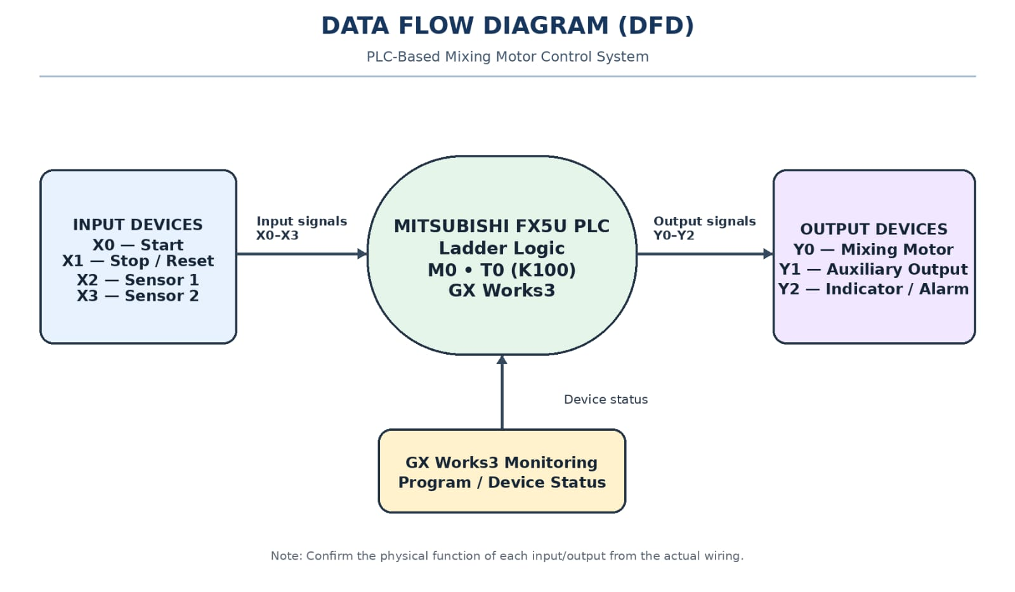

Block Diagram
Figure 2: System Hardware & PLC Interfacing Block Diagram

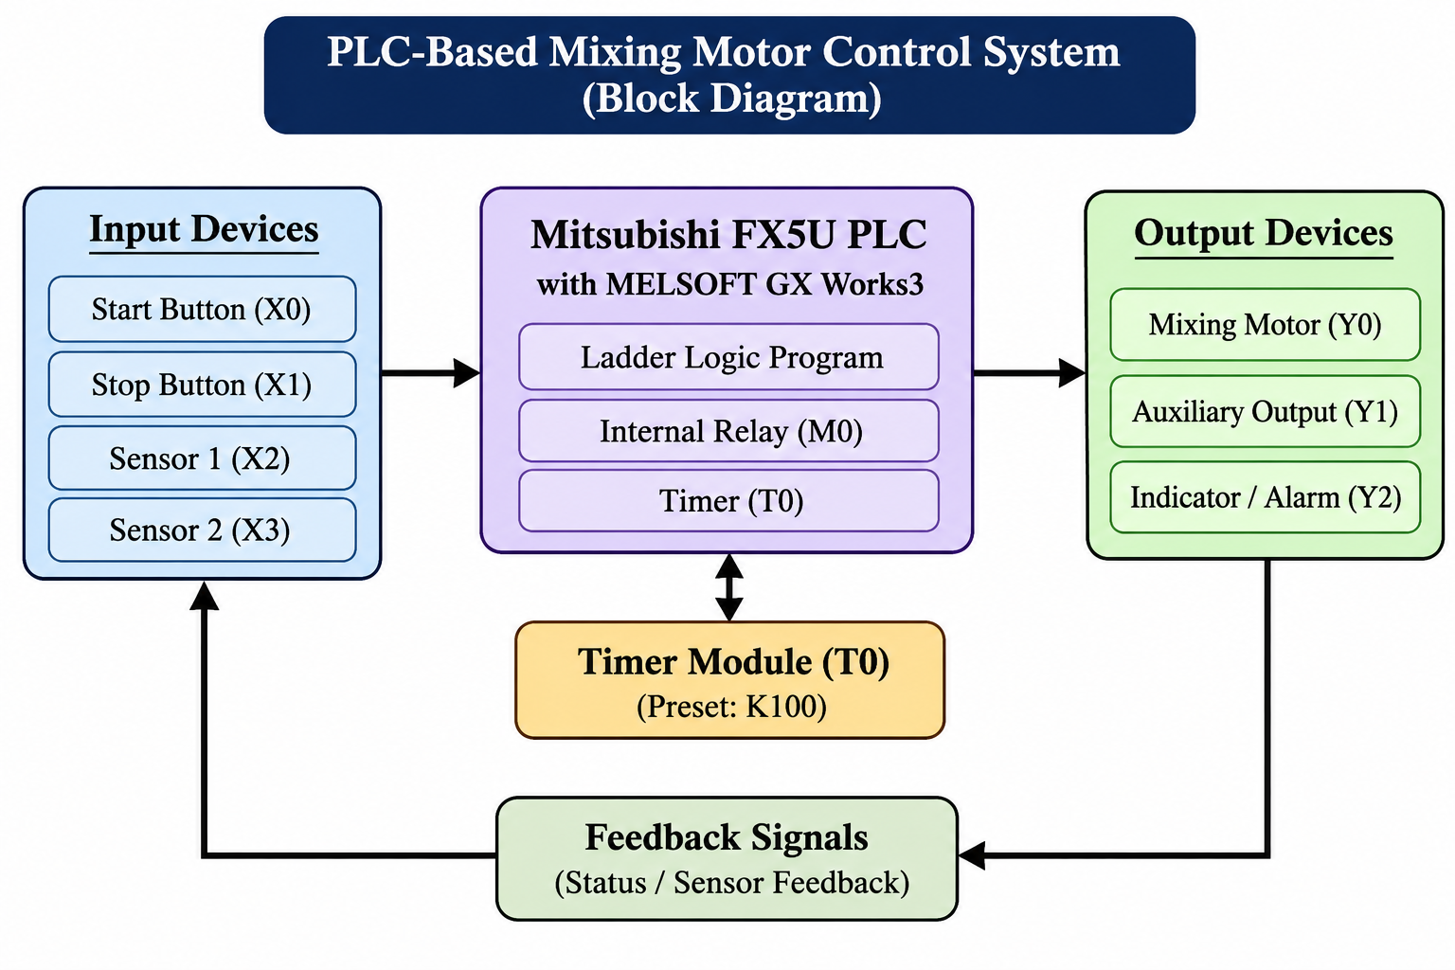

Flow Chart
Figure 3: Dispensing & Fault Watchdog Sequence Flow Chart

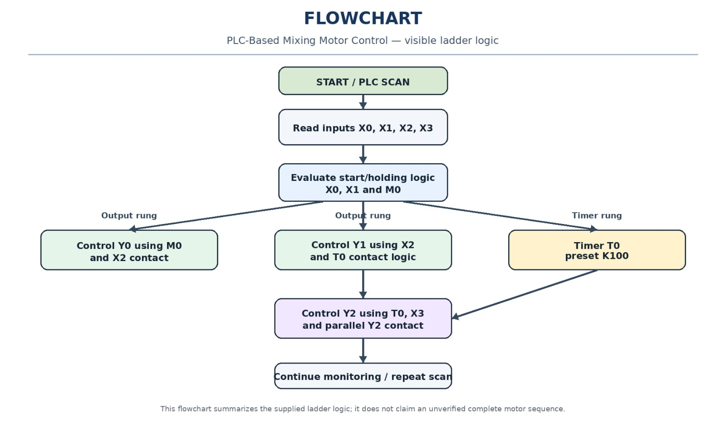

UML & PLC Ladder Diagram
Table 3: Mitsubishi FX5U PLC I/O & Internal Relay Allocation

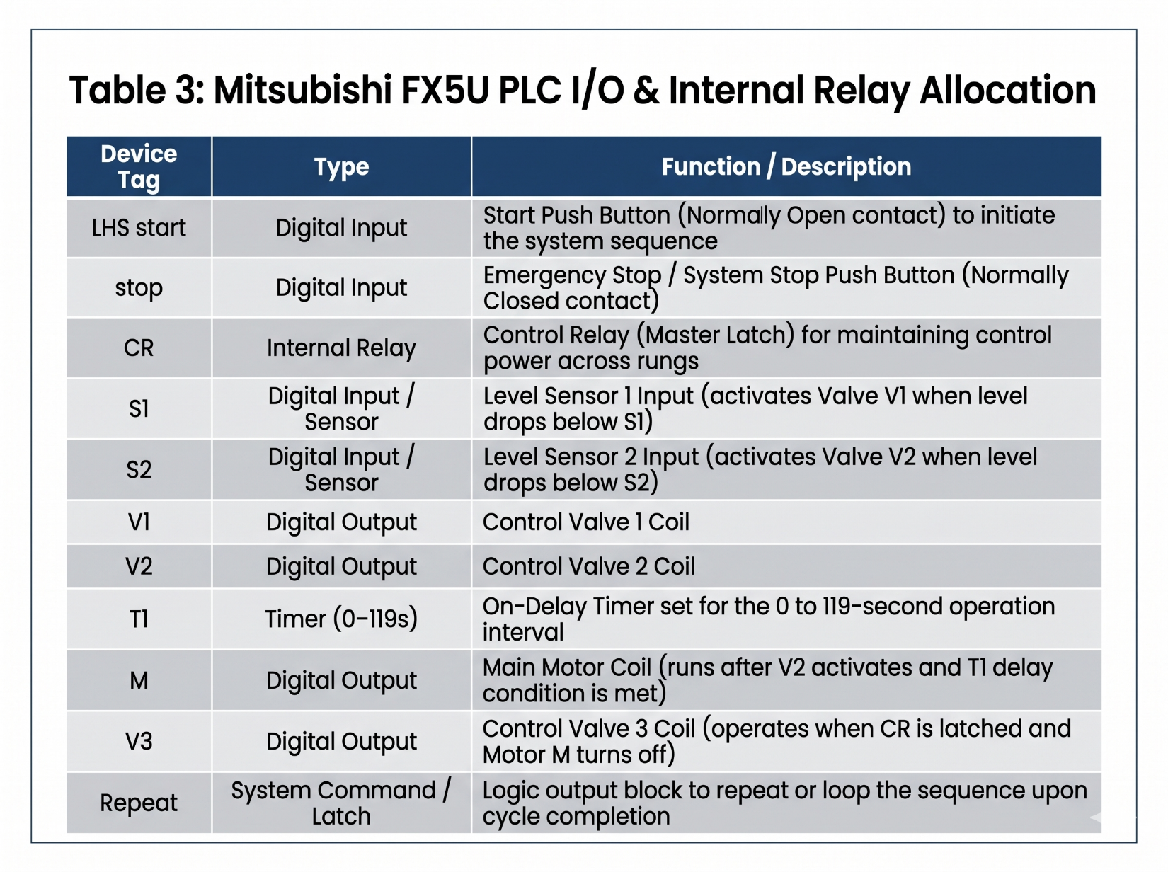

Figure 4: Mitsubishi FX5U PLC Ladder Diagram (MELSOFT GX Works3 Format)

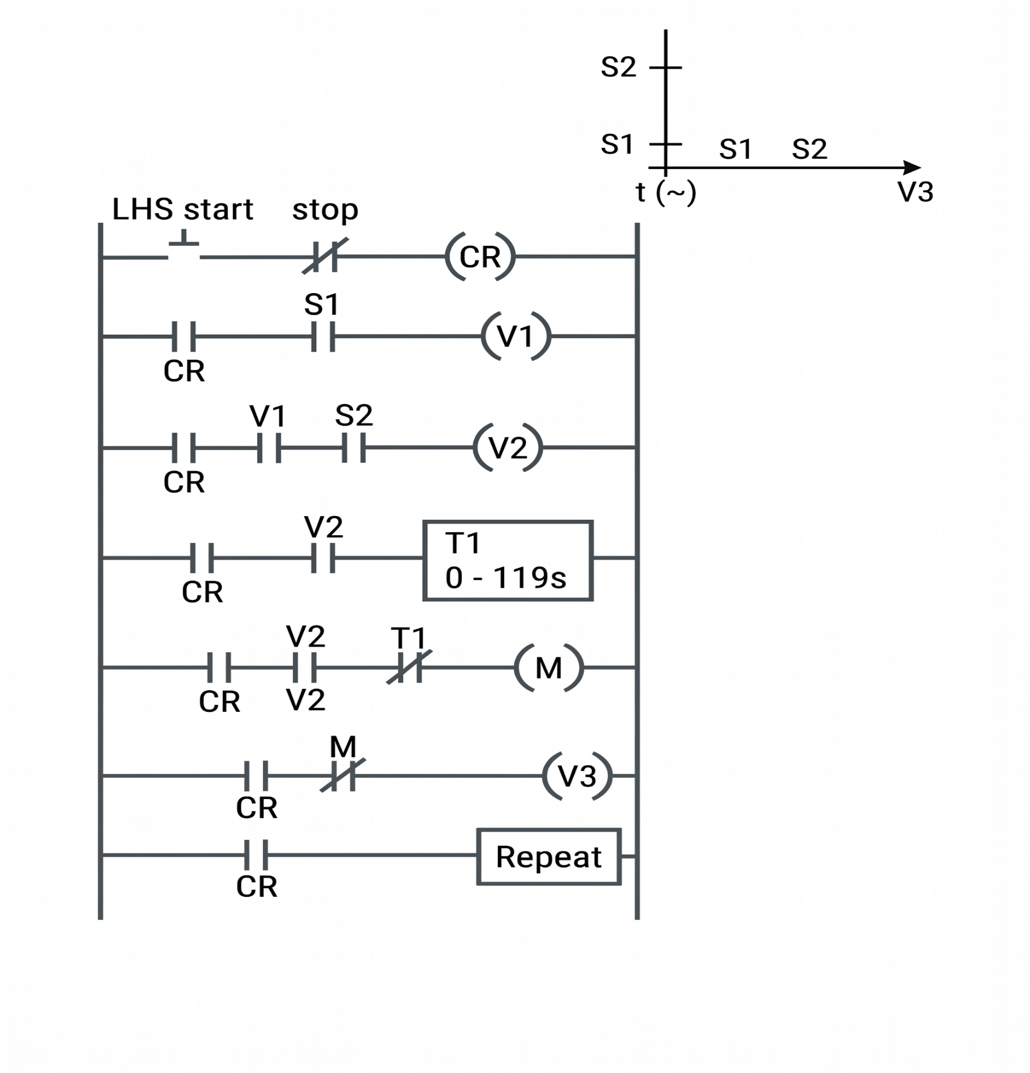

CHAPTER 5: RESULTS & DISCUSSION

Actual Results

The PLC program uses internal relay M0 in a holding circuit.

Output Y0 is controlled by M0 and a normally closed X2 contact.

The Y1 control section includes input X2 and timer T0.

The Y2 control section includes timer/contact logic and a parallel Y2 contact.

The timer preset displayed in the screenshot is K100.

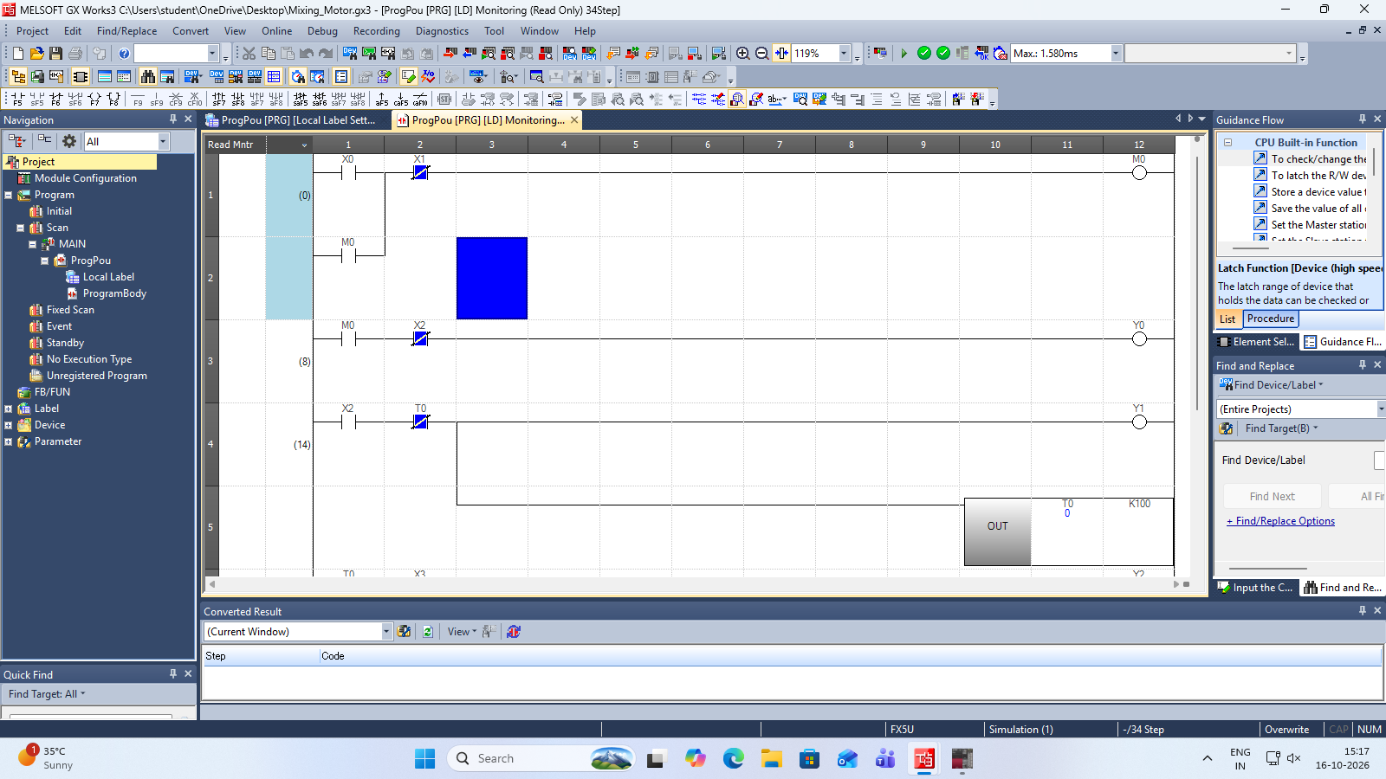

Future Scope
- Automatic Mixing Sequence: Implement a defined sequence for starting, running and stopping the motor according to process requirements.
- Timer Optimization: Configure and verify the timer duration according to the required mixing time.
- Fault Indication: Add suitable fault detection and indication for abnormal operating conditions.
- Operator Interface: Integrate an HMI for start/stop commands, status indication and timer settings.
- Process Monitoring: Add appropriate sensors and monitoring functions where required by the application.
- Safety Improvements: Provide suitable emergency-stop, overload and electrical protection hardware in accordance with the system's design requirements.

CHAPTER 6:CONCLUSION

The PLC-Based Mixing Motor Control System demonstrates the use of Mitsubishi MELSOFT GX Works3 and Ladder Diagram programming to implement industrial control logic using an FX5U PLC.

The visible ladder program incorporates input contacts, a holding circuit using internal relay M0, output coils Y0, Y1 and Y2, and timer T0 with preset K100. These elements illustrate how PLC instructions can be combined to control output states according to input conditions and programmed logic.

The supplied screenshots establish the structure of the visible ladder program. However, confirmation of the complete mixing sequence, timer duration, physical output assignments and overall operational performance requires the corresponding project configuration and test evidence.

The project provides a basis for studying PLC programming, internal relay operation, contact logic, timer-controlled behavior and ladder monitoring in an industrial automation application.

REFERENCES

- 1. Mbeah, A. K., & Normanyo, E. (2024). Automation of a Pharmaceutical Batch Mixer Using Programmable Logic Controller (PLC) and Supervisory Control and Data Acquisition System (SCADA). Automation, Control and Intelligent Systems, 12(4), 71–107. https://doi.org/10.11648/j.acis.20241204.11

- 2. Mahalakshmi, G., Sangeetha, S., Maladhi, et al. (2022). Automation of Industrial Drives Using PLC and SCADA. AIP Conference Proceedings, 2527, 040009. https://doi.org/10.1063/5.0108098

- 3. Chong, Y., Xu, C., Feng, H., Shi, X., Li, J., Du, C., & Wang, J. (2015). One Kind of Control Method Based on PLC of Stepper Motor. In Proceedings of the 2nd International Conference on Civil, Materials and Environmental Sciences, 418–421. https://doi.org/10.2991/cmes-15.2015.116

- 4. Chambers, C., Holcombe, M., & Barnard, J. (2001). Introducing X-machine Models to Verify PLC Ladder Diagrams. Computers in Industry, 45(3), 277–290. https://doi.org/10.1016/S0166-3615(01)00085-9

